Project Planning Phase

**Project Planning Template (Product Backlog, Spirit Planning, Stories, Story points)**

**Product Backlog, Sprint Schedule, and Estimation (4 Marks)**

Use the below template to create product backlog and sprint schedule

|  |  |  |  |  |  |  |
| --- | --- | --- | --- | --- | --- | --- |
| **Spirit** | **Functional Requirement (Epic)** | **User Story Number** | **User Story / Task** | **Story Points** | **Priority** | **Team Members** |
| Spirit-1 | Download The Dataset | USN-1 | We can download the Dataset contains Six classes | 1 | Low | IYYAPPAN.N  MONISH.V | |
| Spirit-1 | Import The ImageDataGenerator Library | USN-2 | We can import ImageDataGenerator | 1 | Low | MONISH.V  JAGANATHAN.K | |
| Spirit-1 | Configure ImageDataGenerator class | USN-3 | We can configure the ImageDataGenerator class | 1 | Low | MOHAMMED SALIM.K  IYYAPPAN.N | |
| Spirit-2 | Apply the ImageDataGenerator | USN-4 | We can apply ImageDataGenerator to train dataset | 2 | Medium | JAGANATHAN.K  IYYAPPAN.N | |

|  |  |  |  |  |  |  |
| --- | --- | --- | --- | --- | --- | --- |
| **Sprint** | **Functional Requirement (Epic)** | **User Story Number** | **User Story / Task** | **Story Points** | **Priority** | **Team Members** |
|  | functionality to Trainset and Dataset |  |  |  |  |  |
| Sprint-1 | Import Libraries | USN-5 | We can import required Libraries | 1 | Low | MOHAMMED SALIM.K |
| Sprint-1 | Initialize the Model | USN-6 | Initializing the Image recognition model | 2 | Medium | MONISH.V  IYYAPPAN.N |
| Sprint-4 | Adding CNN layer | USN-7 | We can add Convolutional Neural Network(CNN) used for image/object recognition and classification | 4 | High | IYYAPPAN.N  JAGANATHAN.K |
| Sprint-4 | Adding Dense Layer | USN-8 | We can add Dense Layer in which each neuron receives input from all the neurons of previous layer | 4 | High | IYYAPPAN.N  JAGANATHAN.K |
| Sprint-4 | Configure The Learning Process | USN-9 | We can configure The Learning process which is a method, mathematical logic or algorithm that improves the network's performance and/or training time. | 4 | High | MONISH.V  IYYAPPAN.N  MOHAMMED SALIM.K |
| Sprint-3 | Train the Model | USN-10 | We can train our model with our image dataset. fit_generator functions used to train a deep learning neural network | 3 | High | MONISH.V  IYYAPPAN.N  MOHAMMED SALIM.K  JAGANATHAN.K |
| Sprint-1 | Save the Model | USN-11 | We can save The model with .h5 extension | 2 | Medium | MONISH.V  IYYAPPAN.N |
| Sprint-2 | Test the model | USN-12 | We can Test the model through Loaded necessary libraries, the saved model | 2 | Medium | MONISH.V  MOHAMMED SALIM.K |

|  |  |  |  |  |  |  |
| --- | --- | --- | --- | --- | --- | --- |
| **Sprint** | **Functional Requirement (Epic)** | **User Story Number** | **User Story / Task** | **Story Points** | **Priority** | **Team Members** |
| Sprint-3 | Create Html files | USN-13 | We use HTML to create the front end part of the web page. | 3 | High | IYYAPPAN.N  MOHAMMED SALIM.K |
| Sprint-4 | Build Python code | USN-14 | We build the flask file ‘app.py’ which is a web framework written in python for server-side scripting. | 4 | High | JAGANATHAN.V  MONISH.V |
| Sprint-1 | Run the App | USN-15 | We can run the App | 2 | Medium | MONISH.V  IYYAPPAN.N  MOHAMMED SALIM.K |
| Sprint-2 | Register IBM Cloud | USN-16 | We can register IBM Cloud | 2 | Medium | MONISH.V  IYYAPPAN.N  MOHAMMED SALIM.K |
| Sprint-3 | Train the model on IBM | USN-17 | We can Train Out model on IBM | 3 | High | MONISH.V  MOHAMMED SALIM.K |

**Project Tracker, Velocity & Burndown Chart: (4 Marks)**

|  |  |  |  |  |  |  |
| --- | --- | --- | --- | --- | --- | --- |
| **Sprint** | **Total Story Points** | **Duration** | **Sprint Start Date** | **Sprint End Date (Planned)** | **Story Points Completed (as on Planned End Date)** | **Sprint Release Date (Actual)** |
| Sprint-1 | 20 | 5 Days | 24 Oct 2022 | 28 Oct 2022 | 20 | 28 Oct 2022 |
| Sprint-2 | 20 | 5 Days | 30 Oct 2022 | 04 Nov 2022 | 20 | 04 Nov 2022 |
| Sprint-3 | 20 | 5 Days | 06 Nov 2022 | 11 Nov 2022 | 20 | 11 Nov 2022 |
| Sprint-4 | 20 | 5 Days | 13 Nov 2022 | 18 Nov 2022 | 20 | 18 Nov 2022 |

# Velocity:

To calculate the team’s **average velocity (AV)** per iteration unit

𝑉𝑒𝑙𝑜𝑐𝑖𝑡𝑦

𝐴𝑣 =

𝑆𝑝𝑟𝑖𝑛𝑡 𝑑𝑢𝑟𝑎𝑡𝑖𝑜𝑛

Where,

**Average Velocity** - Story points per day

**Sprint duration** - Number of days (Duration) for Sprints

**Velocity** - Points per Sprint

Average Velocity is **4** points per Sprint

5

𝐴𝑣 =  20 = 5

# Burndown Chart:

A burndown chart is a graphical representation of work left to do versus time. It is often used in agile [software](https://www.visual-paradigm.com/scrum/what-is-agile-software-development/) [development](https://www.visual-paradigm.com/scrum/what-is-agile-software-development/) methodologies such as [Scrum](https://www.visual-paradigm.com/scrum/scrum-in-3-minutes/). However, burn down charts can be applied to any project containing measurable progress over time.

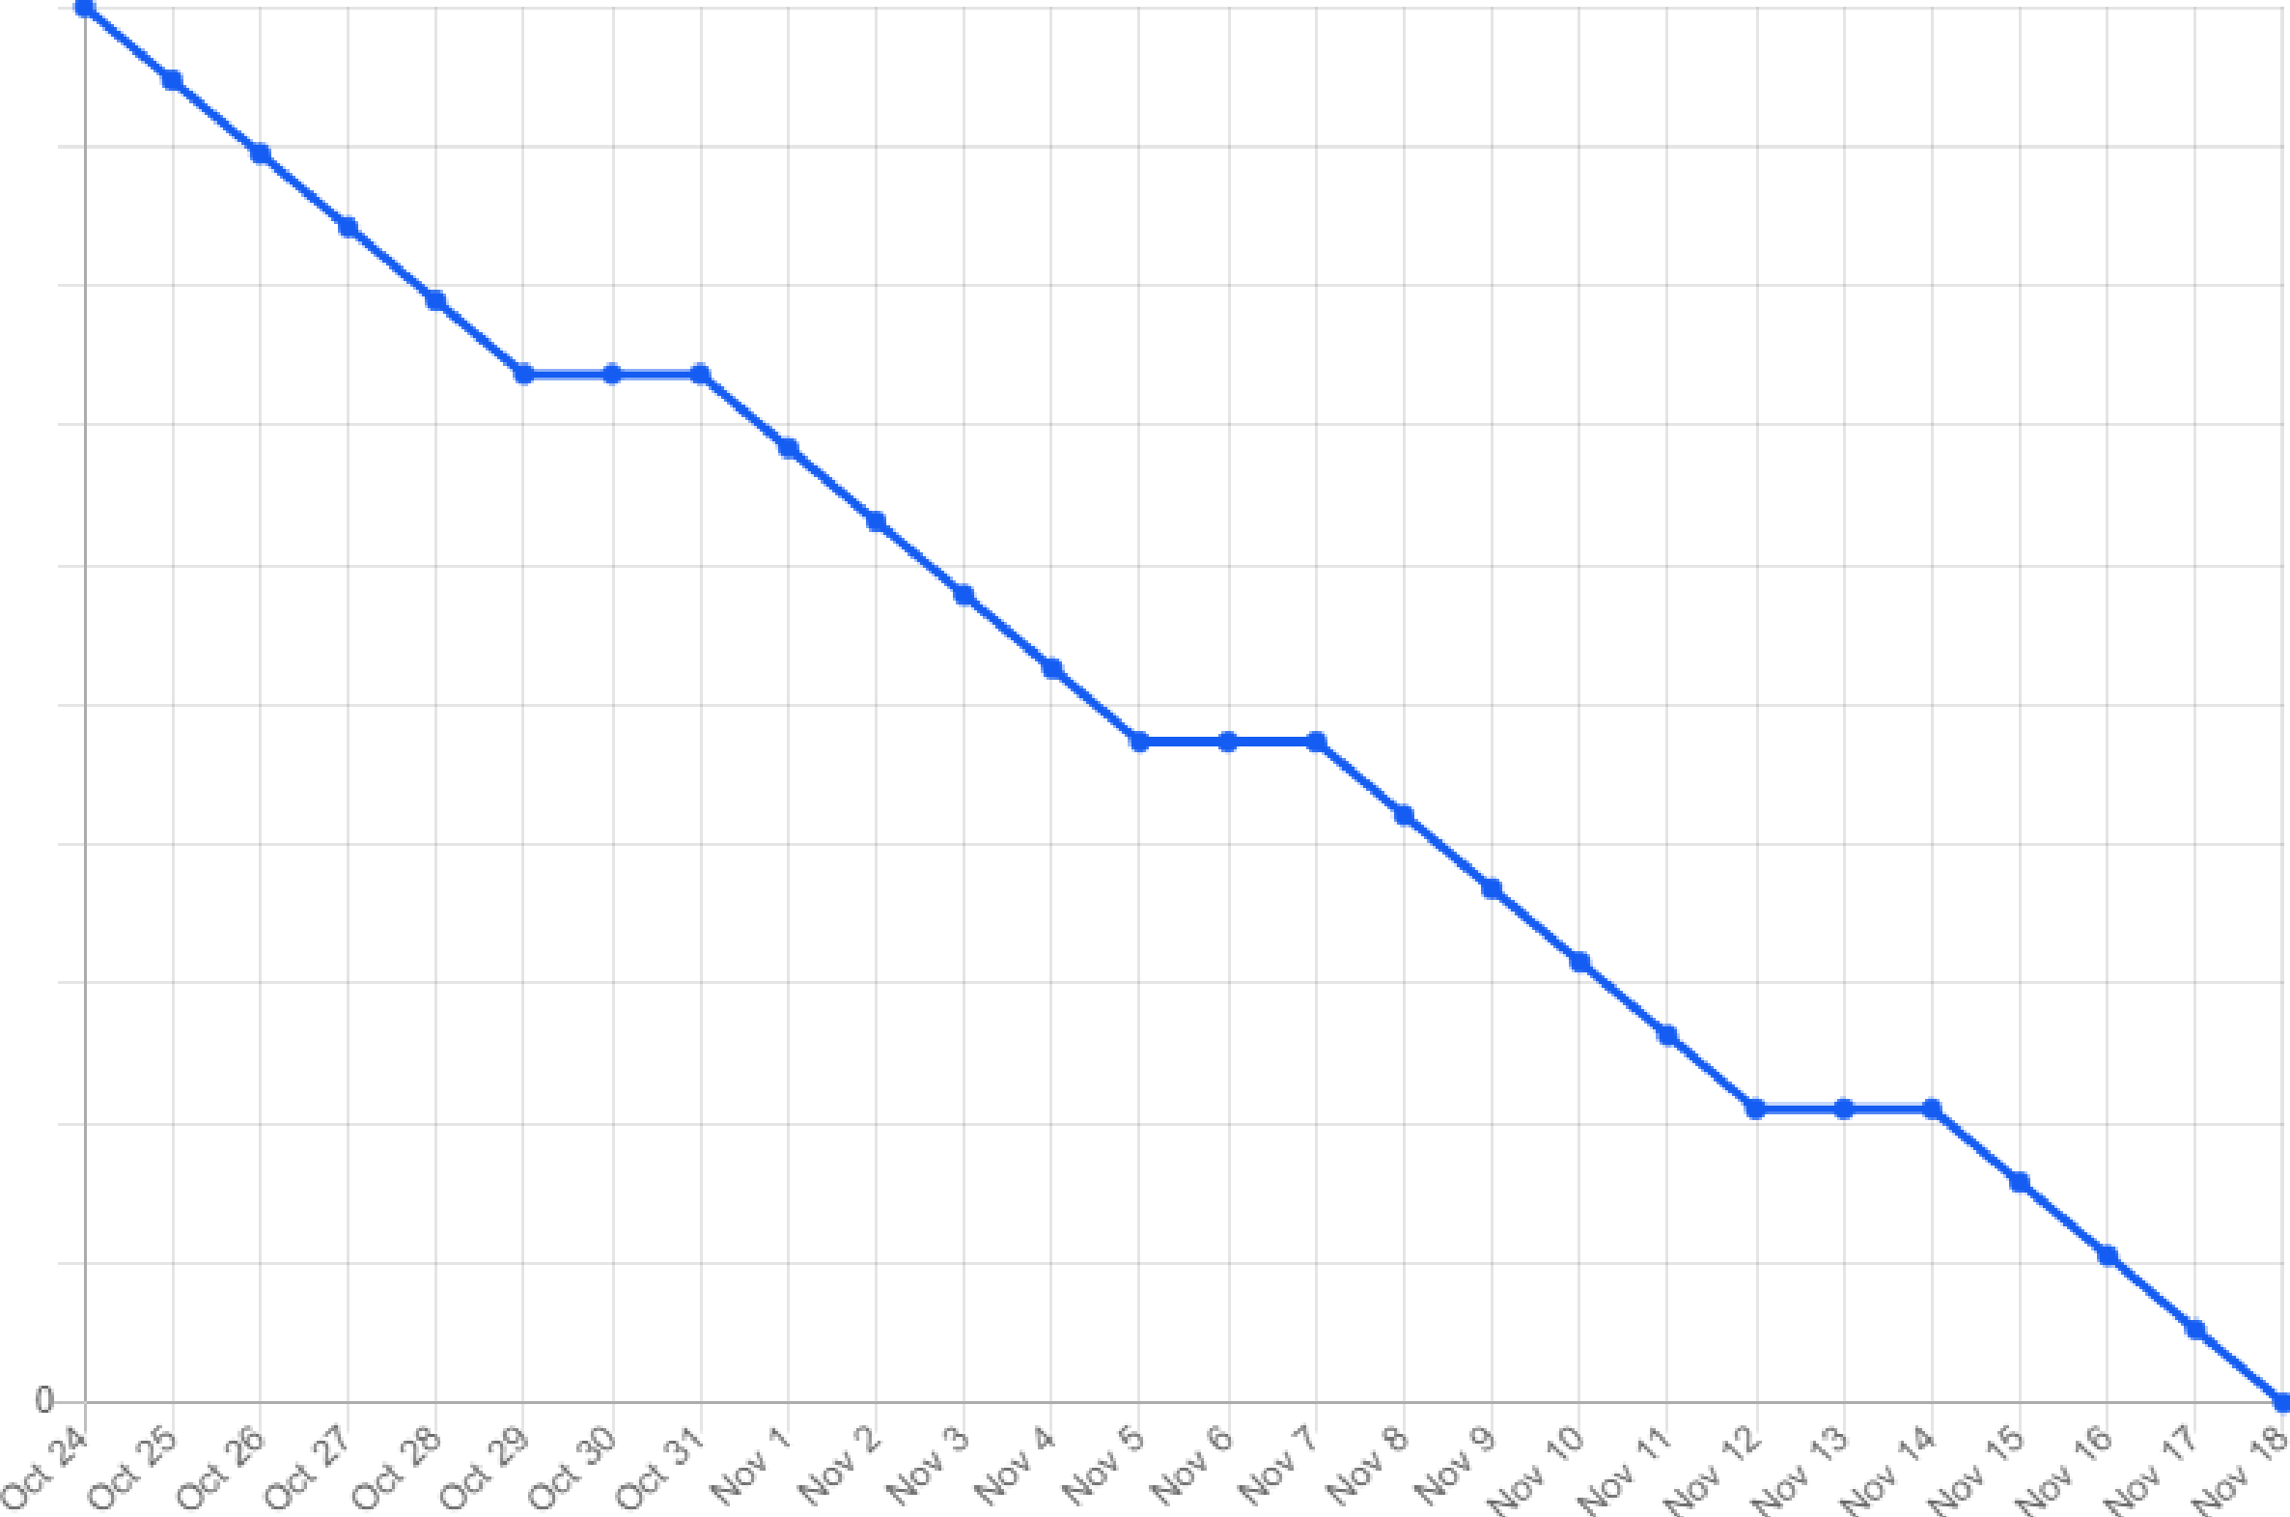IBurnd,own Chart

|  |  |  |  |  |  |  |  |  |  |  |  |  |  |  |  |  |  |
| --- | --- | --- | --- | --- | --- | --- | --- | --- | --- | --- | --- | --- | --- | --- | --- | --- | --- |
| 20 |  | | | | | | | | | | | | | | | | |
| 18 |
| **16** |  |  |  | + | + | + | + |  | + | + | + | + | + | + | + | + | + |
| **14** | + | + |  |  |  |  |  |  | + | + | + | + | + | + | + | + | + |
| **12** | + | +- | + |  |  |  |  | + | + | + | + | +- | + | + | +- | + | + |
| **10** | + | +- | + |  |  |  |  | + | + | + | + | +- | + | + | +- | + | + |
| 8 | + | +- | + | + | +- | + | +- | + |  |  |  |  |  |  |  |  |  |
| 6 | +- | +- | +- | + | +- | + | +- | +- |  |  |  |  |  |  |  |  |  |
| **4** | + | + |  | + | + | + | + |  |  |  |  |  |  |  |  |  |  |
| 2 | + | + |  | + | + | + | + |  |  |  |  |  |  |  |  |  |  |